Persistence in LangGraph
Without persistence, when one graph execution ends, the next execution starts with a fresh state, so the chatbot forgets previous messages.
Persistence allows LangGraph to save the state of a workflow, so it can be retrieved later. It not only stores the final state but can also save intermediate states/checkpoints during the workflow.
Langraph has fault tolerance exactly because of Persistence.
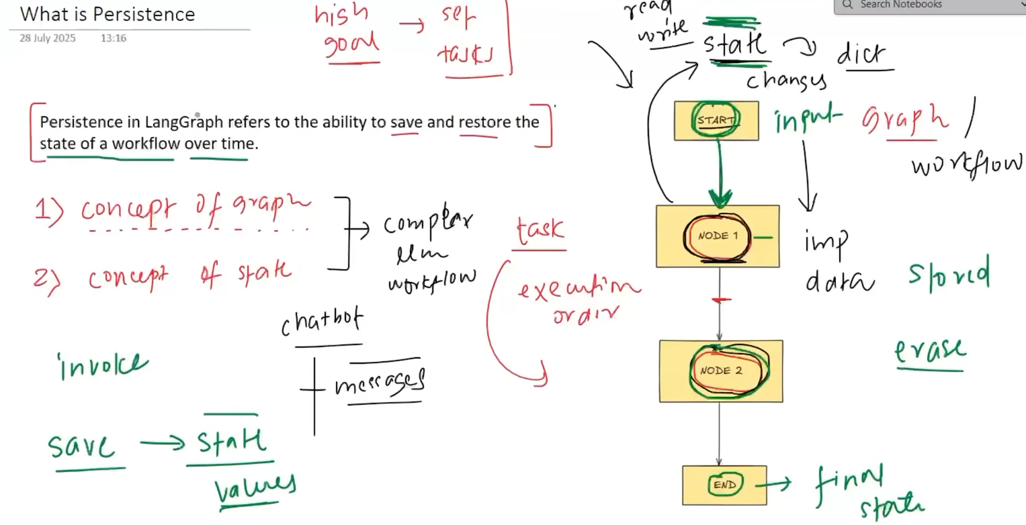

A checkpoint is a saved snapshot of the graph's state at a particular point during execution. It stores things like messages and intermediate values so the workflow can be resumed later.
A super-step is one execution step in LangGraph where one or more nodes can execute together. Nodes that are independent of each other can run in parallel within the same super-step.
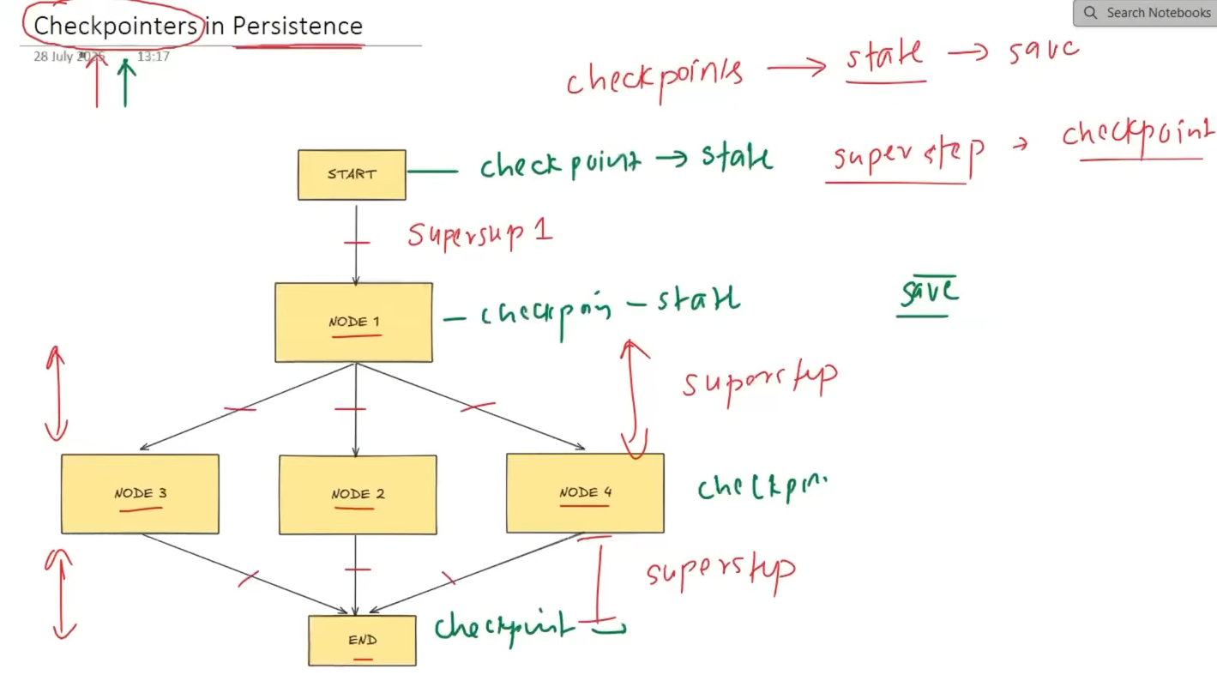
Here we have a variable in state which is storing a list of integers and we are using reducer to add new values to the list not replace it.
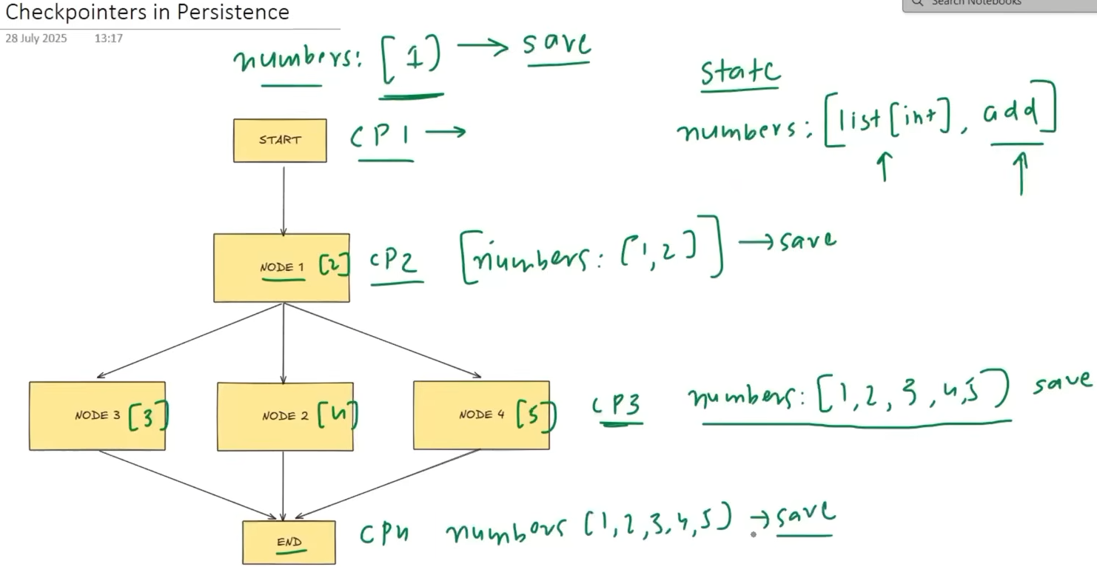
A thread is a unique conversation/workflow session whose state is stored separately from other sessions. LangGraph uses a thread_id to identify that thread and retrieve its previous checkpoints.
Intuition: Think of a thread as a separate folder for one conversation.
Thread is one independent conversation/workflow session.
thread_id = unique identifier for that thread.
We give a topic -> We get a joke -> We get explanation of the joke
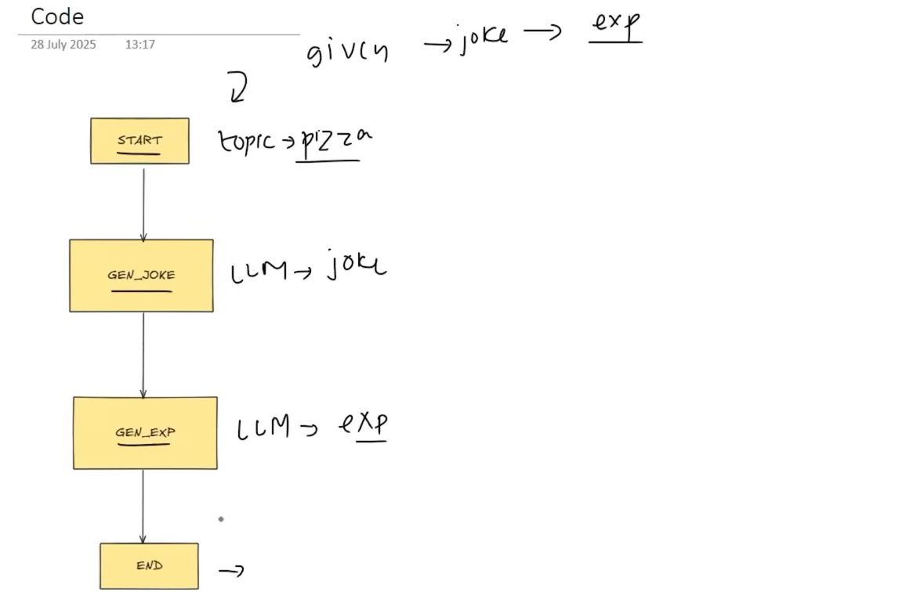

Code:-
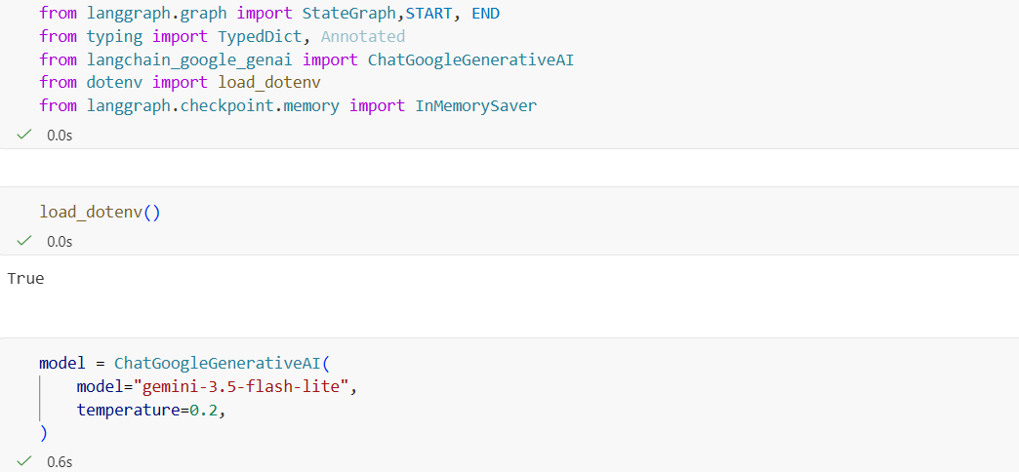
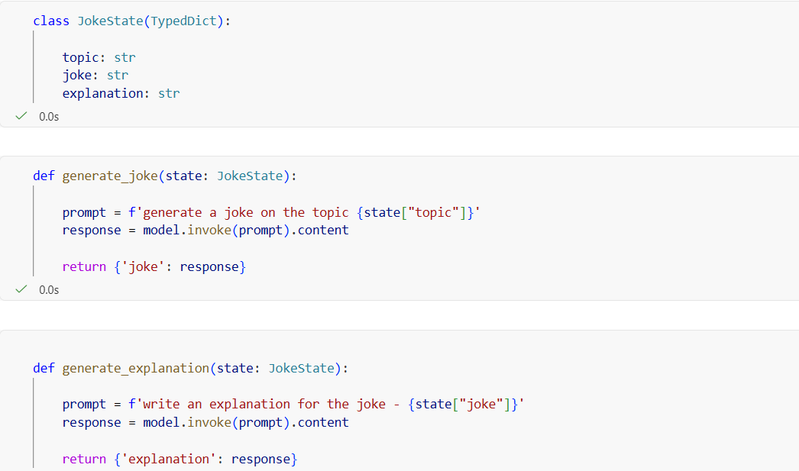

We are using InMemorySaver and give that checkpointer as input to graph.compile to do persistence here.
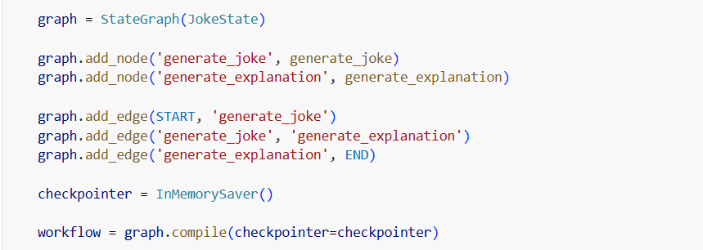
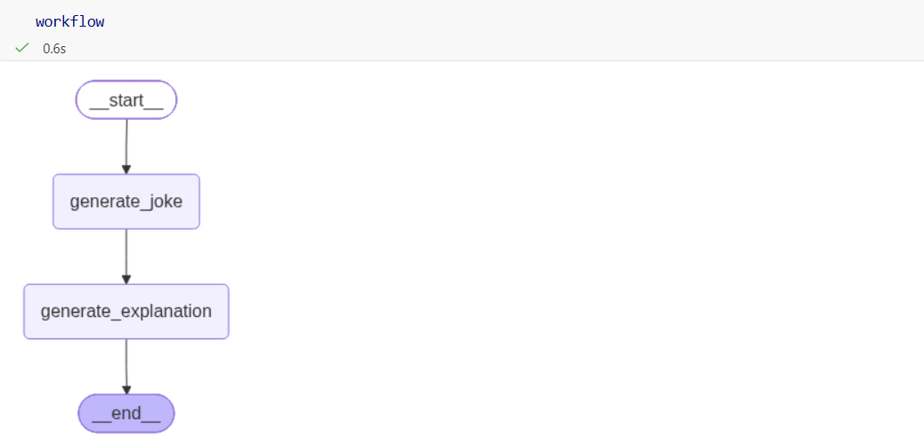
We give thread_id when we create the config. That config goes during workflow invoke.

Here the first code just gives the current final value stored in config1 but second one tells us the history and that involves the intermediate results in each of the node. The lowest has no topic since we have given it topic yet and it shows the next node is __start__ node and 2nd last one shows that topic is given as pizza and hence next node is generate_joke but still text ( joke ) here and in the 3rd last one it shows topic + text and later in line, it shows the next node, which will be generate_explanation and in top line, it shows everything is done so next is empty.
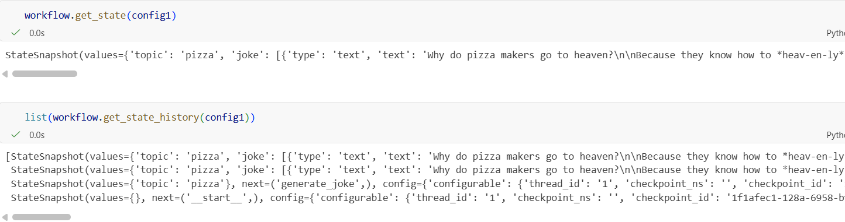
HITL – Human in the loop
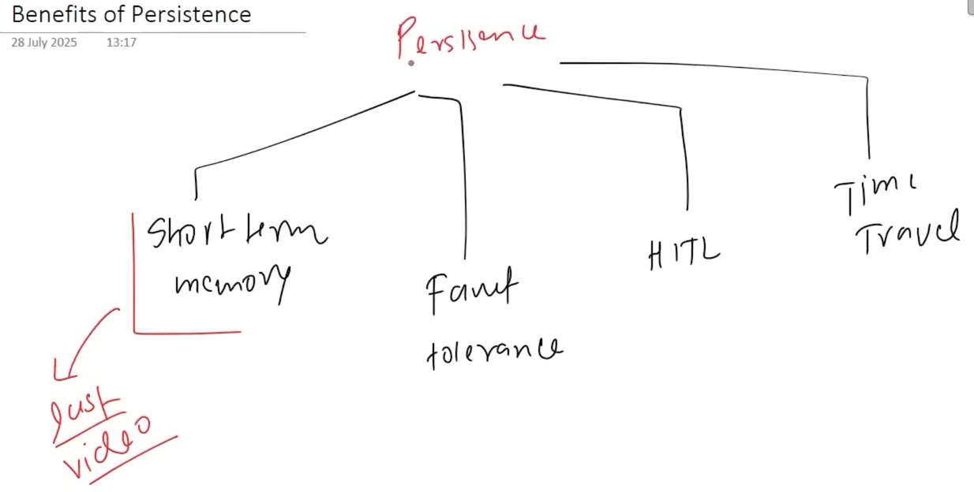

Here at step 2, it will manually stop for 30 second to simulate a crash. And we will see, the work will resume from step 2 again and not from start.
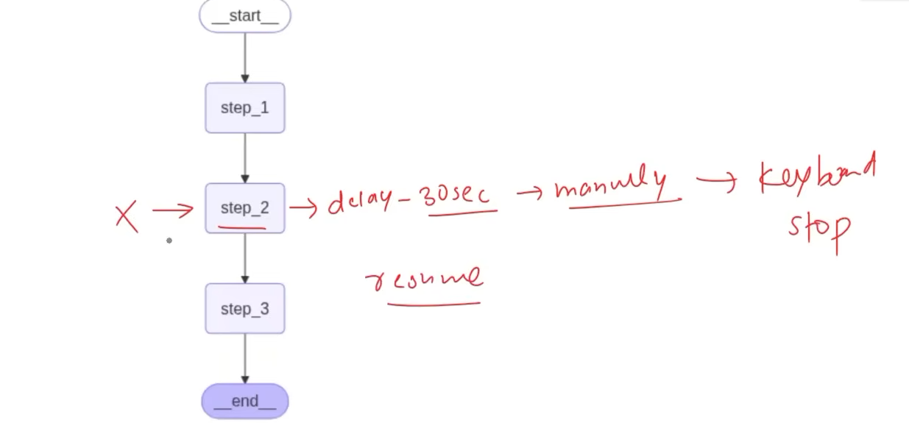

Code:- We are stopping the execution in step 2 for 30 seconds as shown.
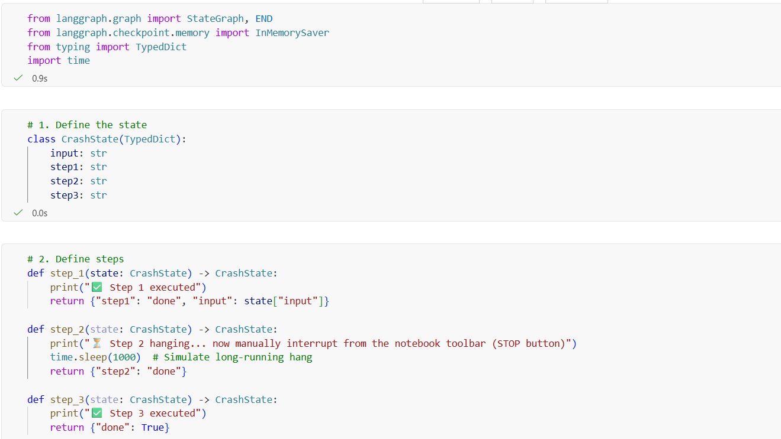

We then stopped the execution in middle of step 2.
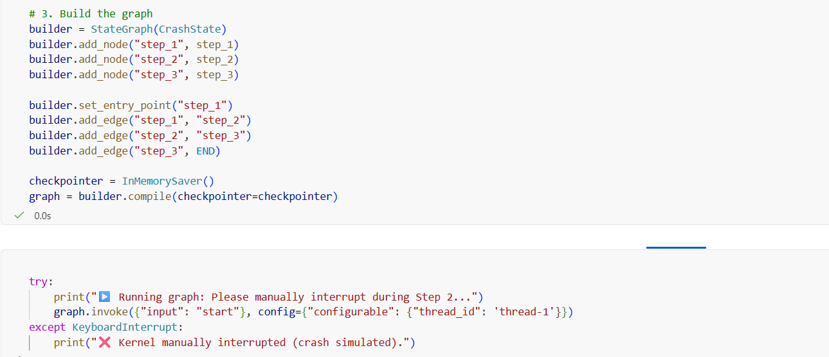
Here it doenst start from step 1 again but it starts from step 2 as we can see. Thead_id should be the same as before.
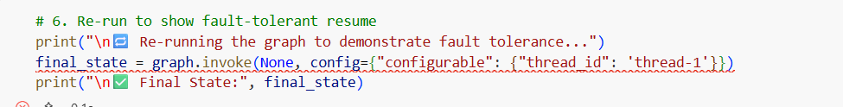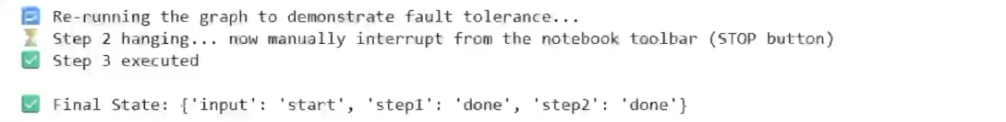

Human in the loop – Here we basically interrupt the program to get the permission or something from human. But how would program know where was the program interupted to start again from that point and that is using persistance.
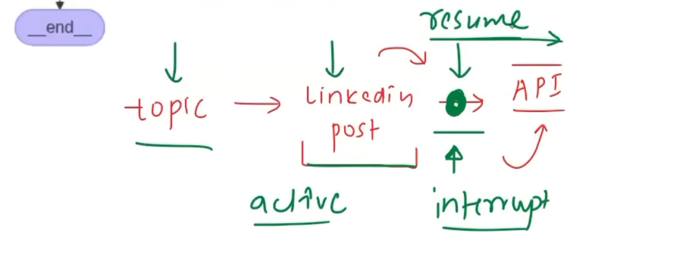
Time travel means using the previous checkpoints of a thread to go back to an earlier state of the workflow and re-run or continue from that point.
- Debugging → see where a workflow went wrong.
- Experimenting → try a different path from an earlier state.
- Human approval → modify something and resume.
- Recovering workflows → continue from a previous checkpoint.

How we find that particular checkpoint is using its checkpoint id. This can be found using .get_state_history and it is different for all of the 4 checkpoints
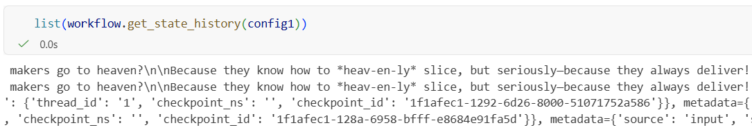

So we gave the checkpoint_id of 2nd checkpoint where joke still hasn’t generated.
Here we rerun the workflow from that specific checkpoint, as we can see. The joke is different and the explanation is different too.
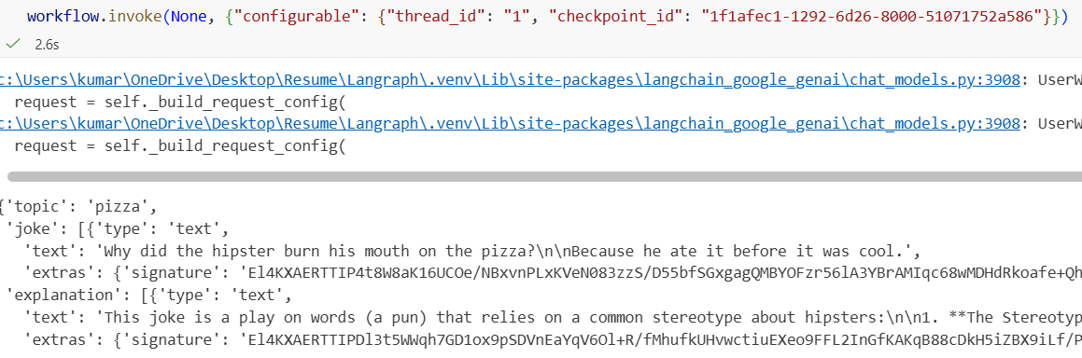
As we can see, it has more checkpoints than before cause we sort of created a branch from checkpoint between __START__ and generate_joke.
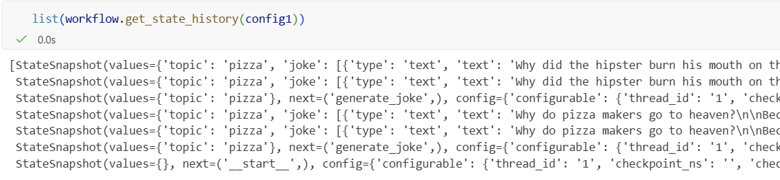
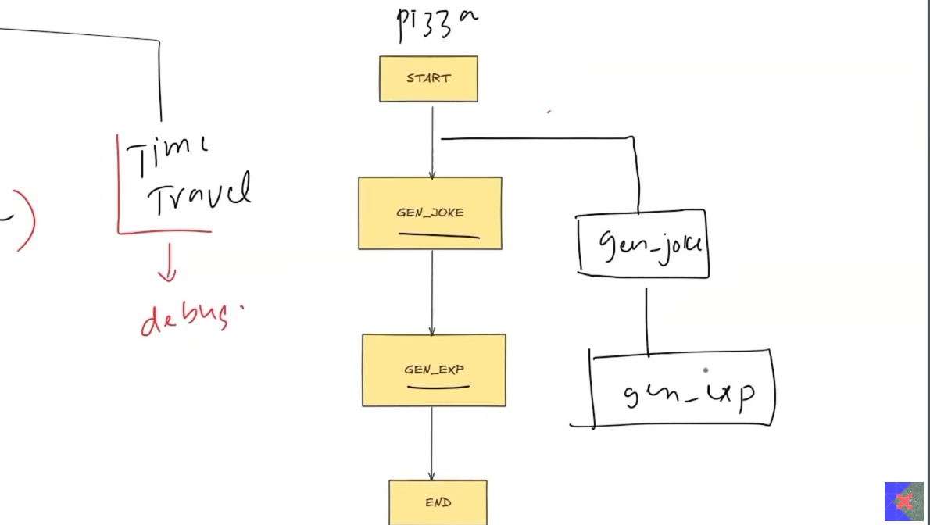

Updating State as in going back and changing the topic. I rerun the whole thing btw.
So here as we can see, samosa is added between __START__ and generate_joke as newest checkpoint. It happened since we updated the topic of joke.
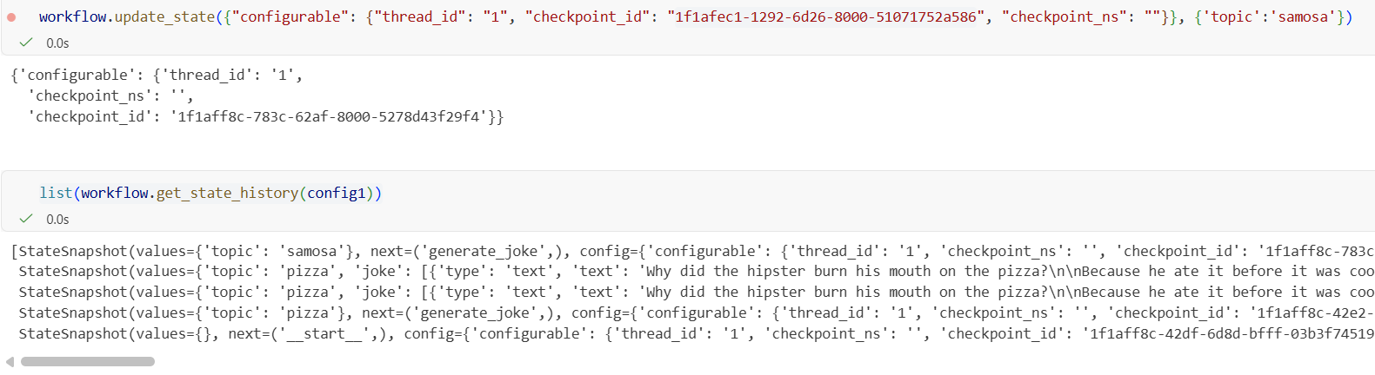
We called workflow again and the checkpoint_id we gave is checkpoint_id of newest checkpoint from previous code so it recognizes the topic as “ samosa “ instead of pizza.
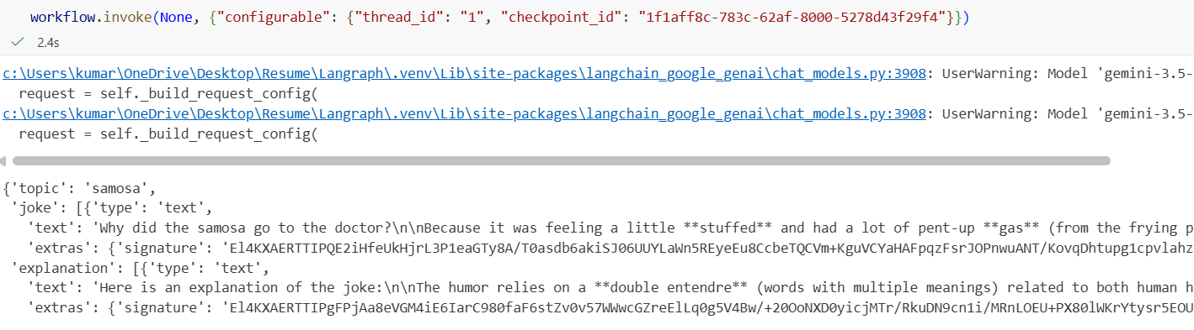
As we can see the difference, there is a joke and explanation about “pizza” and then we change the topic, so it generates about “samosa” now.
